TUTORIAL – 15
Automated Login Testing
Project Name | Automated Login Testing
Module Name | Authentication / Login
Test Case ID | TC-15-01
Tester Name | Vidhi Patel
Application Under Test | SauceDemo Web Application  (https://www.saucedemo.com/)
Tools Used | Python, PyCharm, Selenium WebDriver, Google Chrome
SDLC Model | Agile

Test Scenarios with Screenshots
Scenario LOG01: Open login page
Scenario ID | LOG01
Scenario | Open login page
Test Steps | 1. Run the Python script.  2. Launch the browser.  3. Navigate to https://www.saucedemo.com/.
Expected Result | Login page opens successfully.
Actual Result | Login page opens successfully.
Status | Pass
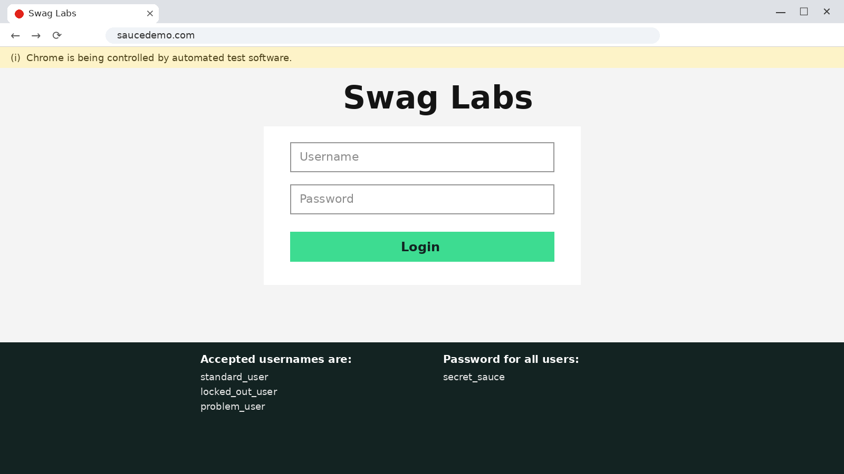
Figure 1: SauceDemo login page opened by Selenium
Scenario LOG02: Valid login (TC-01)
Scenario ID | LOG02
Scenario | Valid login (TC-01)
Test Steps | 1. Enter standard_user and secret_sauce.  2. Click Login.  3. Validate "inventory" in the URL and the "Products" title.
Expected Result | User logs in and the Products page is displayed.
Actual Result | User logs in and the Products page is displayed.
Status | Pass
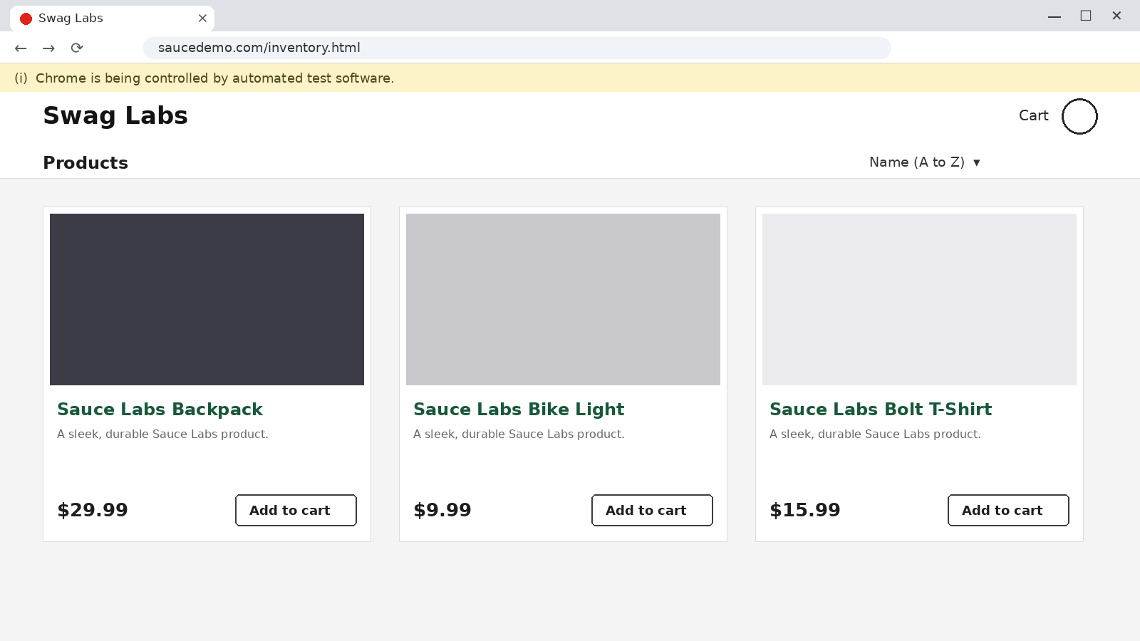
Figure 2: Products page after valid login
Scenario LOG03: Invalid password (TC-02)
Scenario ID | LOG03
Scenario | Invalid password (TC-02)
Test Steps | 1. Enter standard_user and wrong_password.  2. Click Login.  3. Verify the error message.
Expected Result | Error message "Username and password do not match" is displayed.
Actual Result | Error message "Username and password do not match" is displayed.
Status | Pass
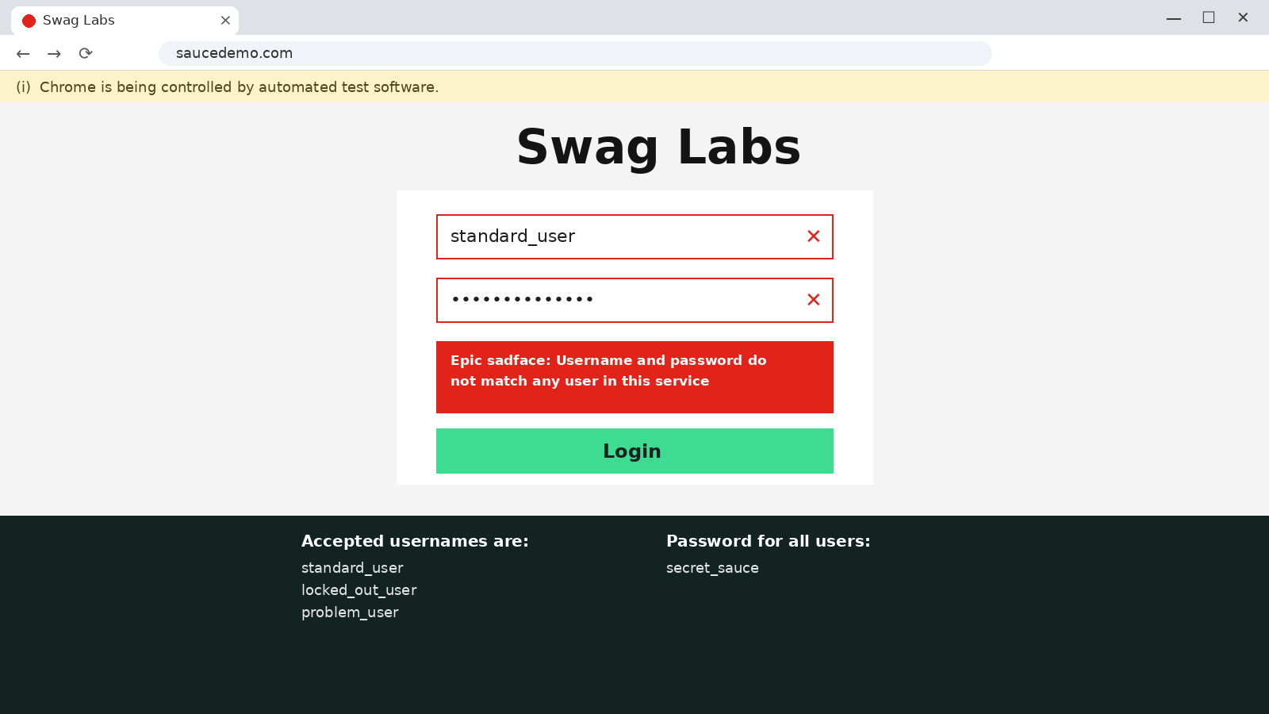
Figure 3: Error message for invalid password
Scenario LOG04: Invalid username (TC-03)
Scenario ID | LOG04
Scenario | Invalid username (TC-03)
Test Steps | 1. Enter wrong_user and secret_sauce.  2. Click Login.  3. Verify the error message.
Expected Result | Error message "Username and password do not match" is displayed.
Actual Result | Error message "Username and password do not match" is displayed.
Status | Pass
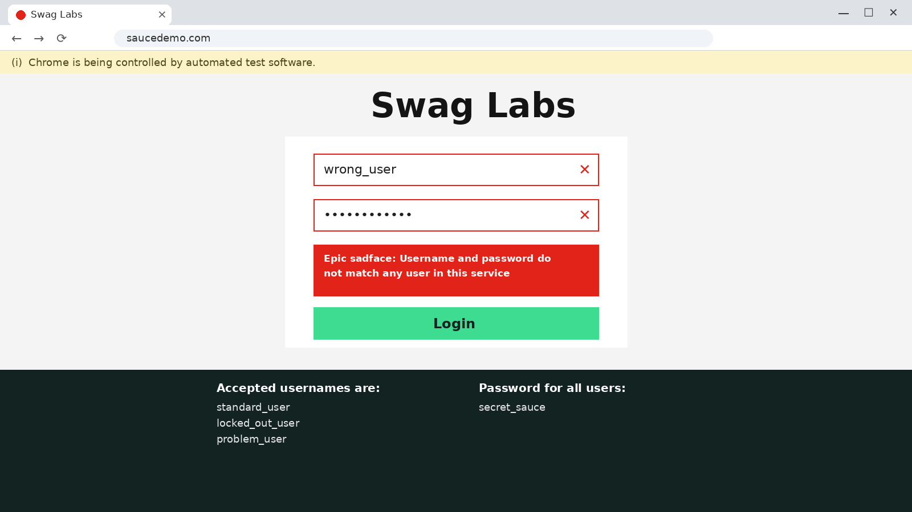
Figure 4: Error message for invalid username
Scenario LOG05: Empty credentials (TC-04)
Scenario ID | LOG05
Scenario | Empty credentials (TC-04)
Test Steps | 1. Leave username and password blank.  2. Click Login.  3. Verify the validation message.
Expected Result | Validation message "Username is required" is displayed.
Actual Result | Validation message "Username is required" is displayed.
Status | Pass
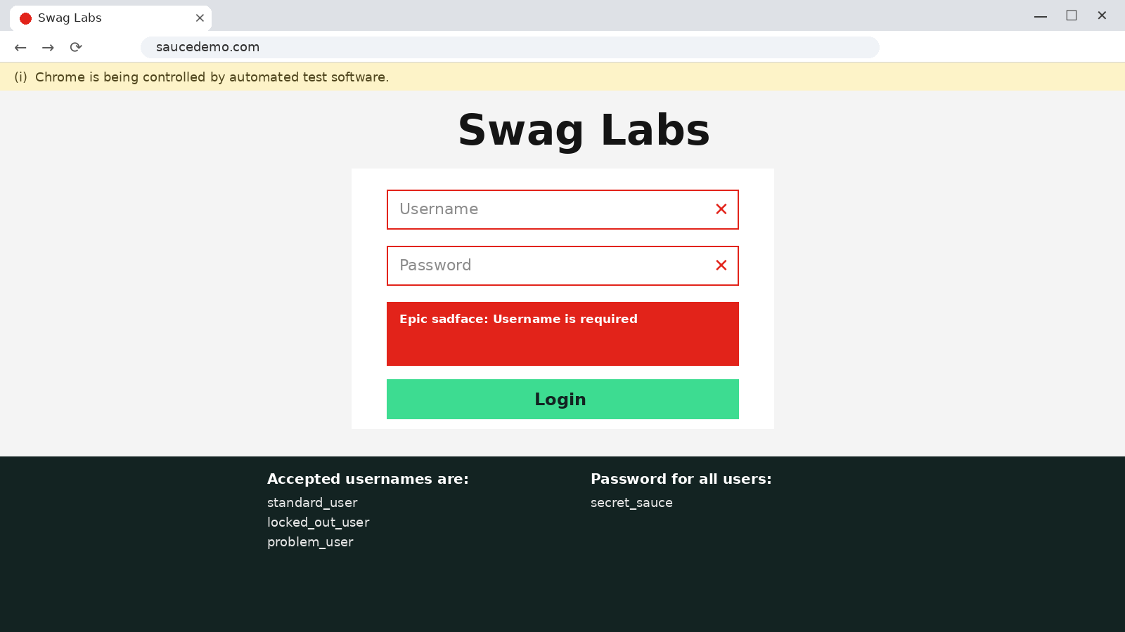
Figure 5: Validation message for empty credentials
Scenario LOG06: Logout (TC-05)
Scenario ID | LOG06
Scenario | Logout (TC-05)
Test Steps | 1. Log in with valid credentials.  2. Open the menu and click Logout.  3. Verify the login page is displayed.
Expected Result | User returns to the login page.
Actual Result | User returns to the login page.
Status | Pass
Figure 6: Login page displayed after logout

Source Code
from selenium import webdriver
from selenium.webdriver.common.by import By
from selenium.webdriver.support.ui import WebDriverWait
from selenium.webdriver.support import expected_conditions as EC
from selenium.common.exceptions import (
NoSuchElementException,
TimeoutException,
ElementNotInteractableException,
StaleElementReferenceException
)

URL = "https://www.saucedemo.com/"
VALID_USERNAME = "standard_user"
VALID_PASSWORD = "secret_sauce"

def start_browser():
driver = webdriver.Chrome()
driver.maximize_window()
return driver

def login(driver, username, password):
driver.get(URL)
wait = WebDriverWait(driver, 10)

username_box = wait.until(
EC.visibility_of_element_located(
(By.ID, "user-name")
)
)
password_box = wait.until(
EC.visibility_of_element_located(
(By.ID, "password")
)
)
login_button = wait.until(
EC.element_to_be_clickable(
(By.ID, "login-button")
)
)

username_box.clear()
username_box.send_keys(username)
password_box.clear()
password_box.send_keys(password)
login_button.click()

# TC-01 Valid Login
def test_valid_login():
driver = start_browser()
try:
login(
driver,
VALID_USERNAME,
VALID_PASSWORD
)
WebDriverWait(driver, 10).until(
EC.url_contains("inventory")
)
assert "inventory" in driver.current_url

products_title = WebDriverWait(
driver, 10
).until(
EC.visibility_of_element_located(
(By.CLASS_NAME, "title")
)
)
assert products_title.text == "Products"

print("TC-01 Valid Login: PASS")
print("Authentication Assertion: PASS")
except AssertionError:
print("TC-01 Valid Login: FAIL")
except NoSuchElementException:
print("NoSuchElementException handled")
except TimeoutException:
print("TimeoutException handled")
except ElementNotInteractableException:
print(
"ElementNotInteractableException handled"
)
except StaleElementReferenceException:
print(
"StaleElementReferenceException handled"
)
finally:
driver.quit()

# TC-02 Invalid Password
def test_invalid_password():
driver = start_browser()
try:
login(
driver,
VALID_USERNAME,
"wrong_password"
)
error_message = WebDriverWait(
driver, 10
).until(
EC.visibility_of_element_located(
(
By.CSS_SELECTOR,
"h3[data-test='error']"
)
)
)
assert (
"Username and password do not match"
in error_message.text
)
print("TC-02 Invalid Password: PASS")
except AssertionError:
print("TC-02 Invalid Password: FAIL")
except TimeoutException:
print("Error message was not displayed")
finally:
driver.quit()

# TC-03 Invalid Username
def test_invalid_username():
driver = start_browser()
try:
login(
driver,
"wrong_user",
VALID_PASSWORD
)
error_message = WebDriverWait(
driver, 10
).until(
EC.visibility_of_element_located(
(
By.CSS_SELECTOR,
"h3[data-test='error']"
)
)
)
assert (
"Username and password do not match"
in error_message.text
)
print("TC-03 Invalid Username: PASS")
except AssertionError:
print("TC-03 Invalid Username: FAIL")
except TimeoutException:
print("Error message was not displayed")
finally:
driver.quit()

# TC-04 Empty Credentials
def test_empty_credentials():
driver = start_browser()
try:
driver.get(URL)
login_button = WebDriverWait(
driver, 10
).until(
EC.element_to_be_clickable(
(By.ID, "login-button")
)
)
login_button.click()
error_message = WebDriverWait(
driver, 10
).until(
EC.visibility_of_element_located(
(
By.CSS_SELECTOR,
"h3[data-test='error']"
)
)
)
assert (
"Username is required"
in error_message.text
)
print("TC-04 Empty Credentials: PASS")
except AssertionError:
print("TC-04 Empty Credentials: FAIL")
except TimeoutException:
print("Validation message was not displayed")
finally:
driver.quit()

# TC-05 Logout
def test_logout():
driver = start_browser()
try:
login(
driver,
VALID_USERNAME,
VALID_PASSWORD
)
WebDriverWait(driver, 10).until(
EC.url_contains("inventory")
)
menu_button = WebDriverWait(
driver, 10
).until(
EC.element_to_be_clickable(
(By.ID, "react-burger-menu-btn")
)
)
menu_button.click()
logout_button = WebDriverWait(
driver, 10
).until(
EC.element_to_be_clickable(
(By.ID, "logout_sidebar_link")
)
)
logout_button.click()
WebDriverWait(driver, 10).until(
EC.visibility_of_element_located(
(By.ID, "login-button")
)
)
assert "saucedemo.com" in driver.current_url
print("TC-05 Logout: PASS")
except AssertionError:
print("TC-05 Logout: FAIL")
except TimeoutException:
print("Logout operation timed out")
finally:
driver.quit()

# Execute all test cases
test_valid_login()
test_invalid_password()
test_invalid_username()
test_empty_credentials()
test_logout()
Source Code Screenshots
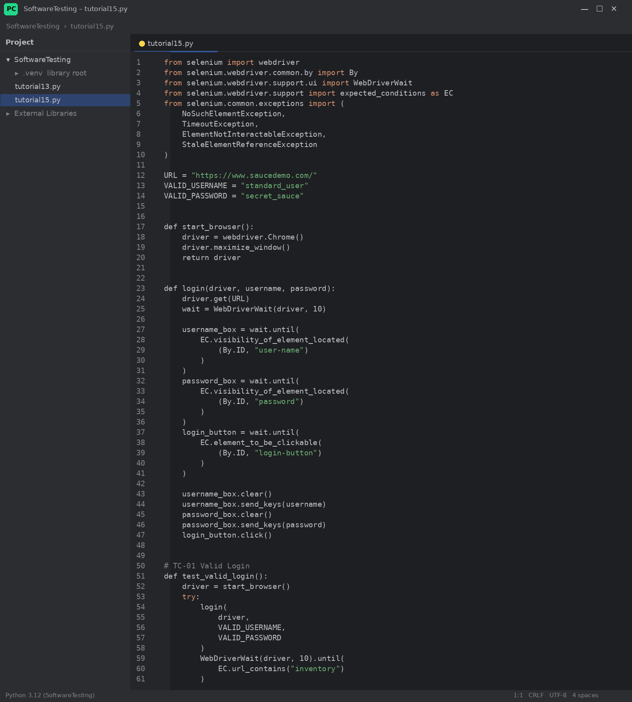
Figure 7: tutorial15.py (part 1)
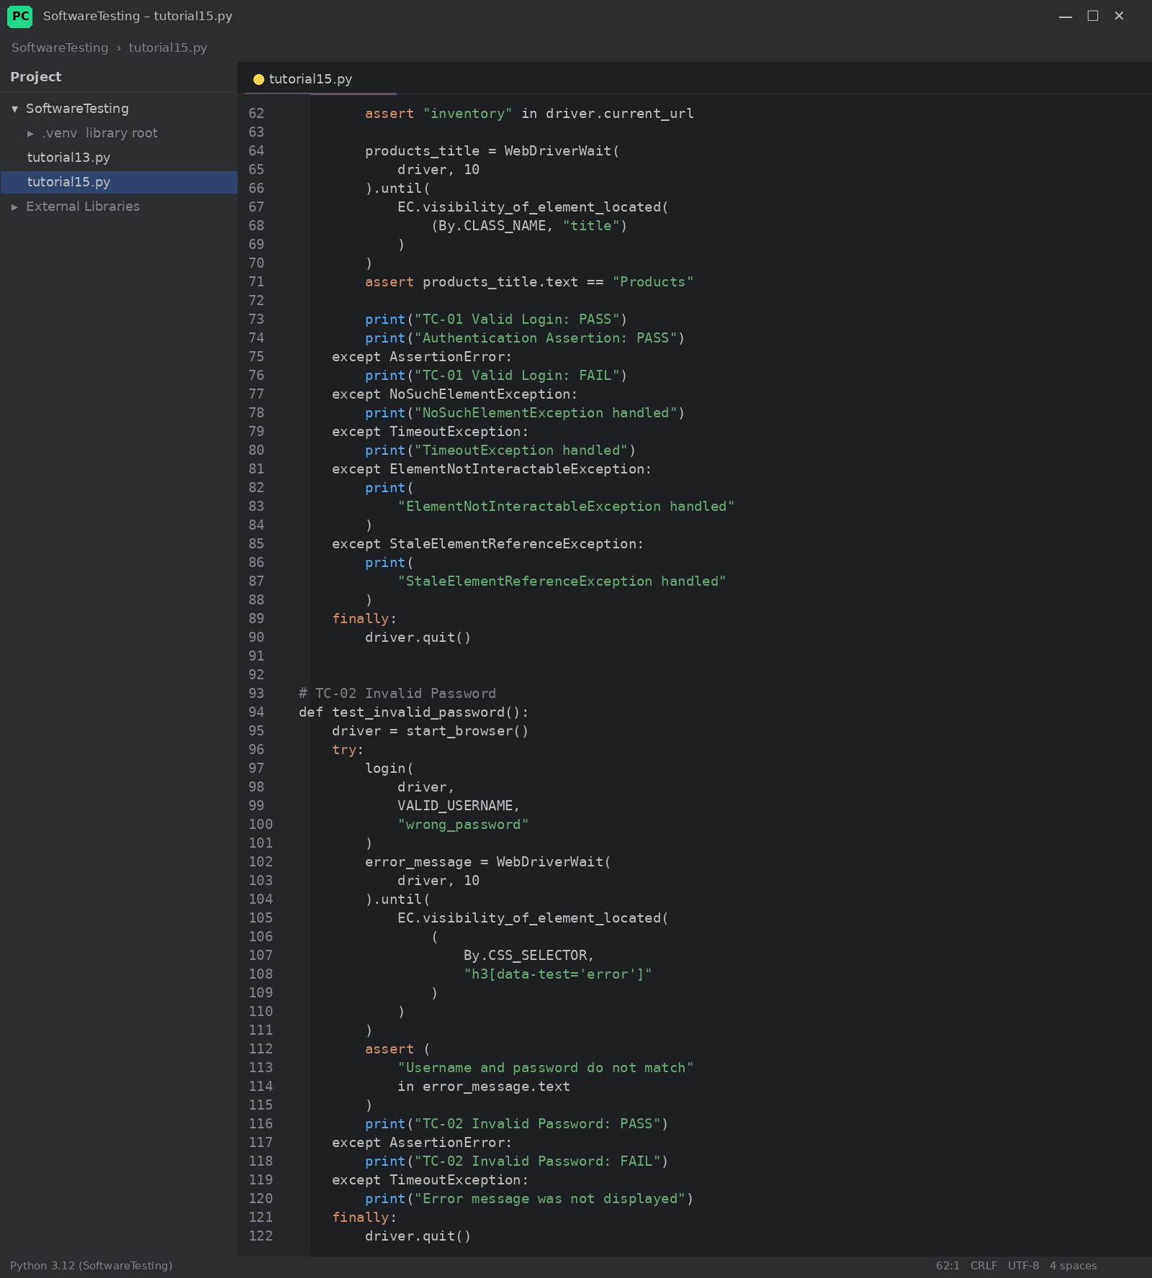
Figure 8: tutorial15.py (part 2)
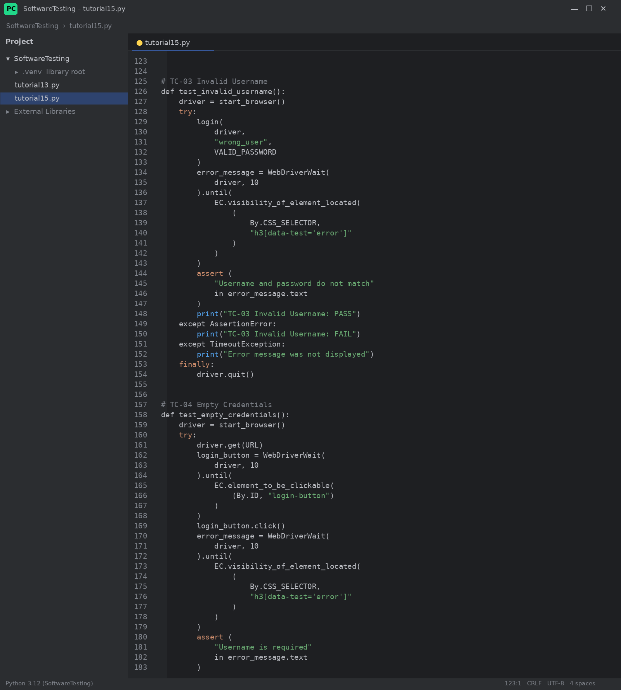
Figure 9: tutorial15.py (part 3)
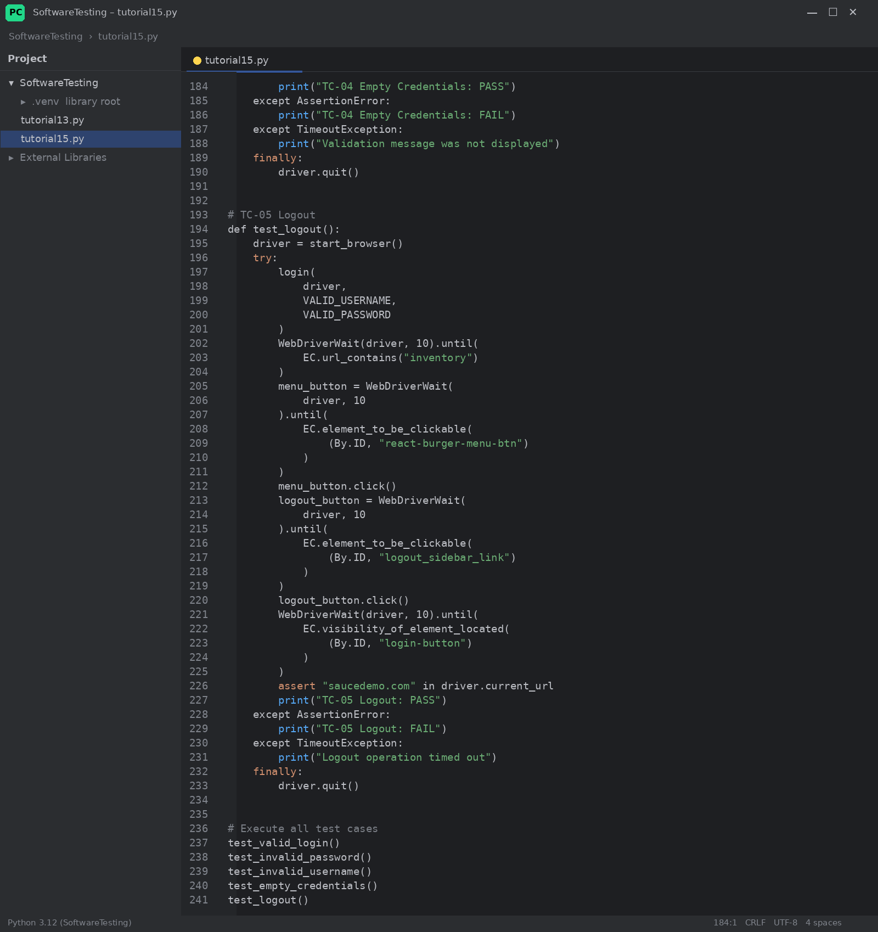
Figure 10: tutorial15.py (part 4)

Console Output
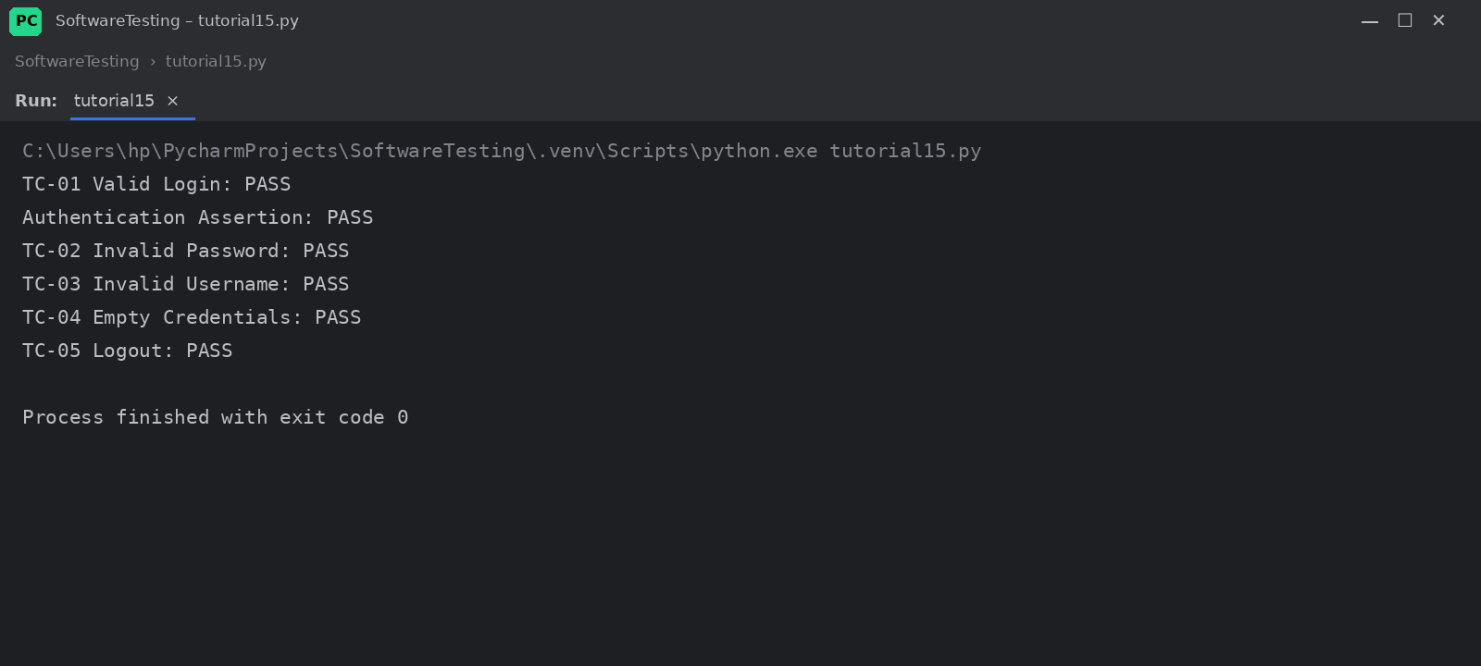
Figure 11: Console output of the executed script
Output:
TC-01 Valid Login: PASS
Authentication Assertion: PASS
TC-02 Invalid Password: PASS
TC-03 Invalid Username: PASS
TC-04 Empty Credentials: PASS
TC-05 Logout: PASS

